**Лабораторна робота №12**

**Тема**: Створення веб-сторінки із використанням серверних скриптів.

**Мета** : Оволодіти базовими навичками по створенню серверних скриптів на базі мови програмування PHP та веб серверу Apache.

**Порядок виконання роботи**

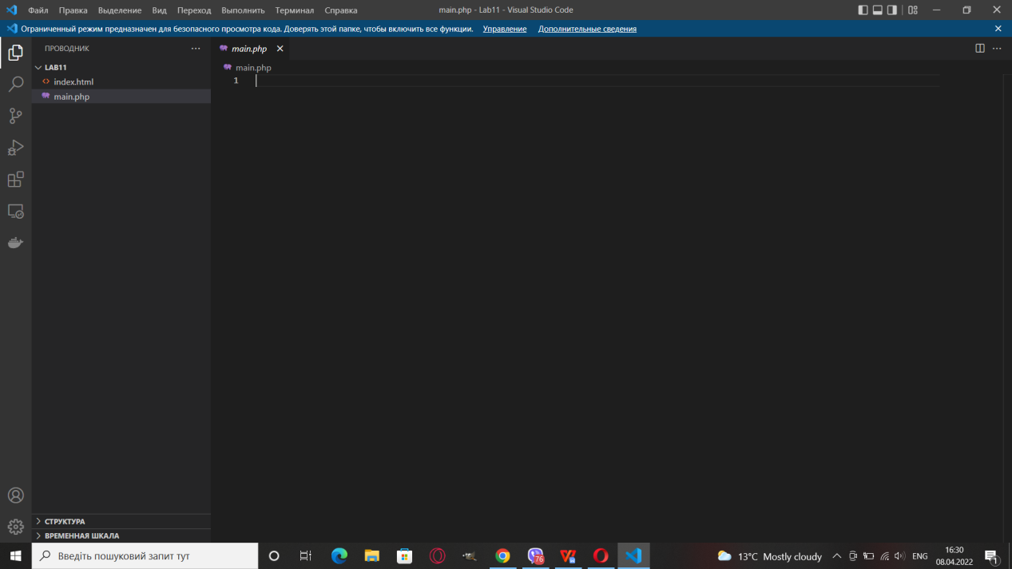

Редактор VS CODE

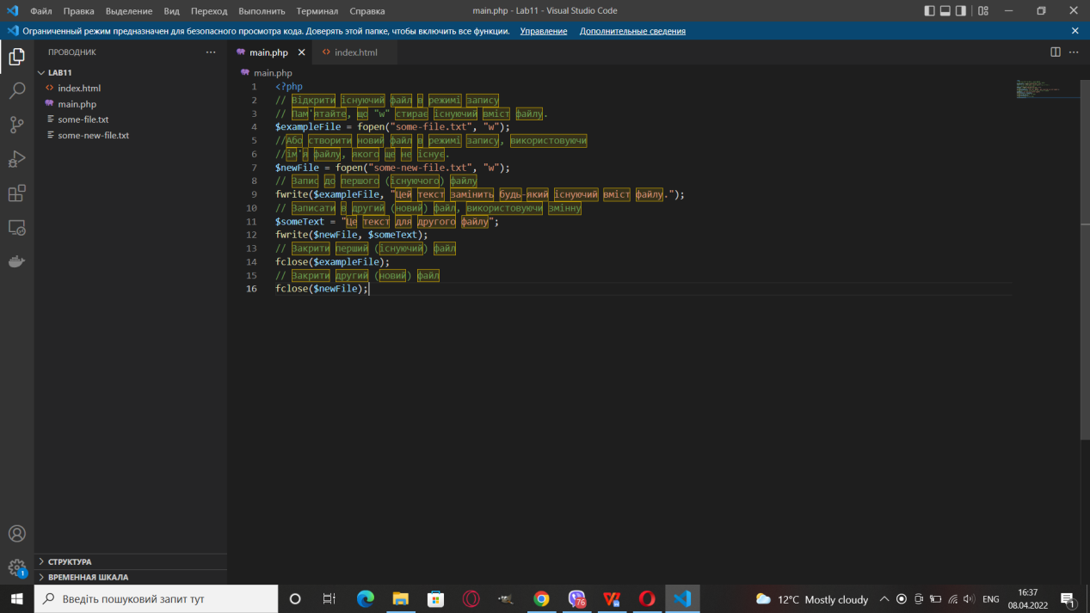

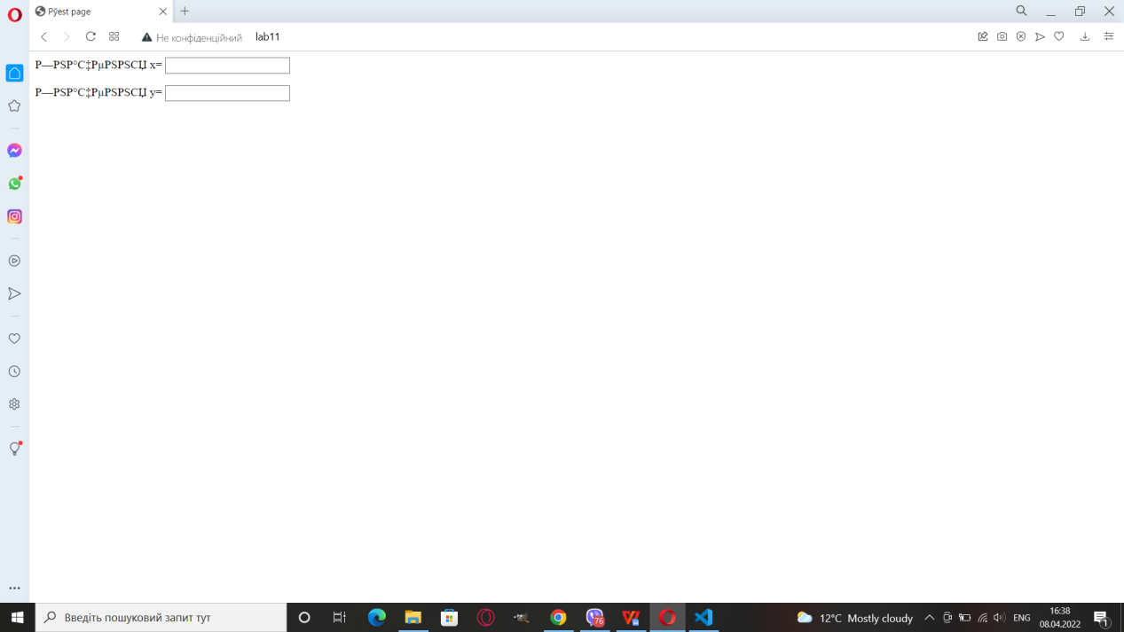

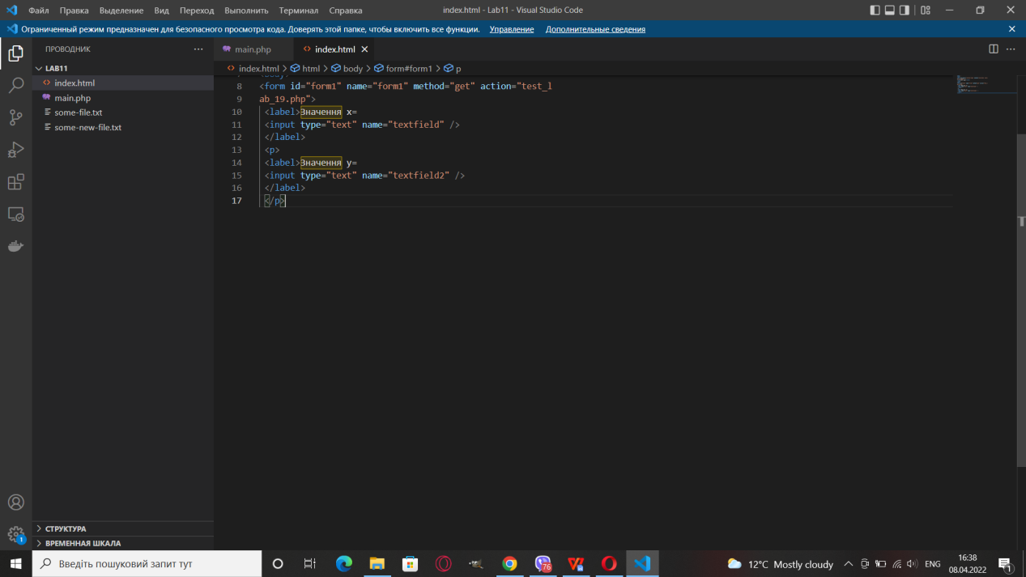

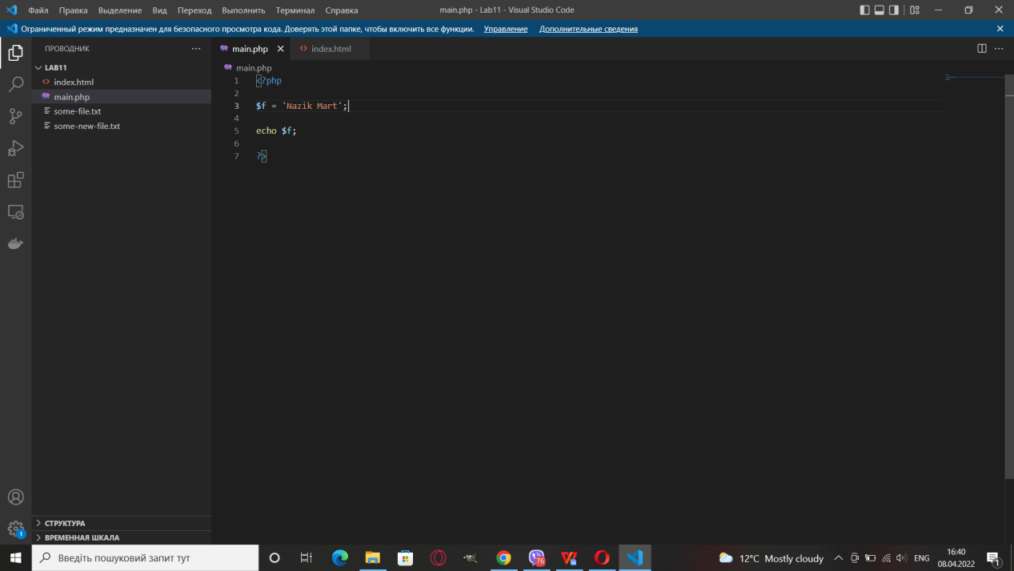

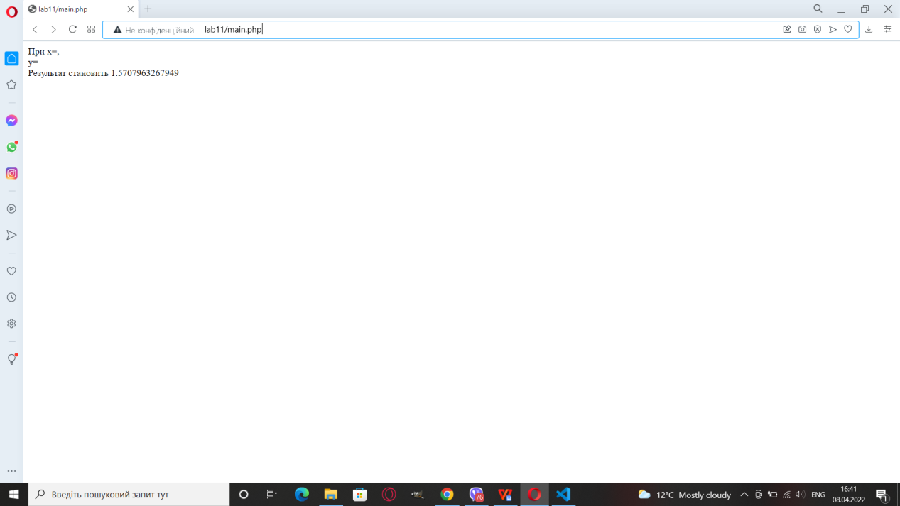

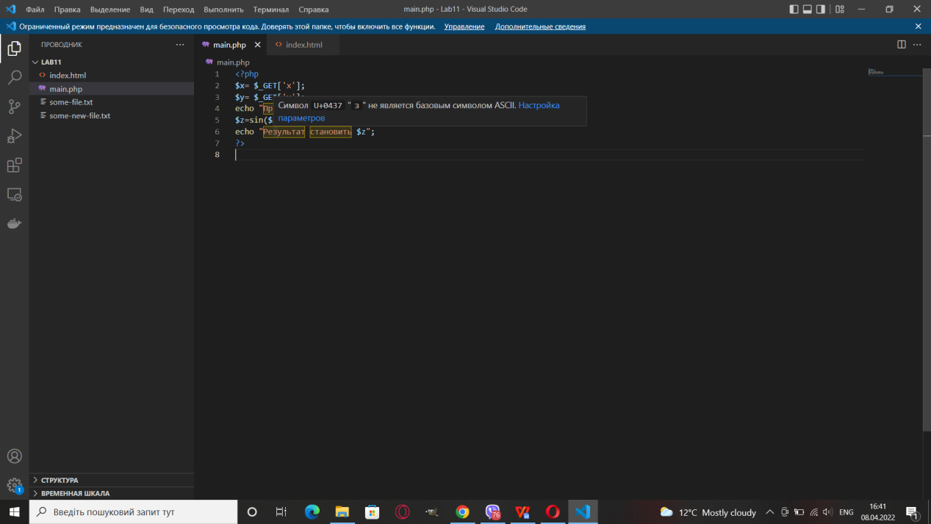

Калькулятор на Bootstrap

HTML

<!doctype html>

<html lang="en">

  <head>

    <meta charset="utf-8">

    <meta name="viewport" content="width=device-width, initial-scale=1">

    <link href="https://cdn.jsdelivr.net/npm/bootstrap@5.0.2/dist/css/bootstrap.min.css" rel="stylesheet" integrity="sha384-EVSTQN3/azprG1Anm3QDgpJLIm9Nao0Yz1ztcQTwFspd3yD65VohhpuuCOmLASjC" crossorigin="anonymous">

    <title>Hello, world!</title>

    <link rel="stylesheet" href="stile.css">

  </head>

  <body>

<div class="container">

  <div class="row rowItem">

    <div class="col-lg-12 col-md-12 col-sm-12 block-items">

      <div class="row">

        <div class="col-lg-12 col-md-12 col-sm-12 dani">

          <span class="spanN">КАЛЬКУЛЯТОР</span>

          <form action="" name="textviev">

  <input type="text" class="form-control paddinp" placeholder="0" name="text" readonly>

</form>

        </div>

      </div>

      <div class="container">

        <div class="row">

          <div class="col-lg-1 col-md-1 col-sm-12 znak" id="znak1" onclick="Insert('+')">+</div>

          <div class="col-lg-1 col-md-1 col-sm-12 znak" id="znak2" onclick="Insert('-')">-</div>

          <div class="col-lg-1 col-md-1 col-sm-12 znak" id="znak3" onclick="Insert('*')">*</div>

          <div class="col-lg-1 col-md-1 col-sm-12 znak" id="znak4" onclick="Insert('/')">/</div>

          <div class="col-lg-1 col-md-1 col-sm-12 znak" id="znak5" onclick="Insert('%')">%</div>

          <div class="col-lg-4 col-md-4 col-sm-12 znak znakColor" id="zna6" onclick="nazik()">=</div>

          <div class="col-lg-3 col-md-3 col-sm-12 znak znakColorC" id="zna6" onclick="Insertt('')">CLEAR</div>

        </div>

      <div class="row">

        <div class="col-lg-4 col-md-4 col-sm-4 divItems" id="items" onclick="Insert('1')">1</div>

        <div class="col-lg-4 col-md-4 col-sm-4 divItems" id="items1" onclick="Insert('2')">2</div>

        <div class="col-lg-4 col-md-4 col-sm-4 divItems" id="items2" onclick="Insert('3')">3</div>

      </div>

      <div class="row">

        <div class="col-lg-4 col-md-4 col-sm-4 divItems" id="items3" onclick="Insert('4')">4</div>

        <div class="col-lg-4 col-md-4 col-sm-4 divItems" id="items4" onclick="Insert('5')">5</div>

        <div class="col-lg-4 col-md-4 col-sm-4 divItems" id="items5" onclick="Insert('6')">6</div>

      </div>

      <div class="row">

        <div class="col-lg-4 col-md-4 col-sm-4 divItems" id="items6" onclick="Insert('7')"> 7</div>

        <div class="col-lg-4 col-md-4 col-sm-4 divItems" id="items7" onclick="Insert('8')">8</div>

        <div class="col-lg-4 col-md-4 col-sm-4 divItems " id="items8" onclick="Insert('9')">9</div>

      </div>

      <div class="row">

        <div class="col-lg-2 col-md-2 col-sm-12 divItems divItemsSsss2" id="items9" onclick="Insert('0')">0</div>

        <div class="col-lg-2 col-md-2 col-sm-12 divItems divItemsSs" id="items9" onclick="Insert('(')">(</div>

        <div class="col-lg-2 col-md-2 col-sm-12 divItems divItemsSs" id="items9" onclick="Insert(')')">)</div>

        <div class="col-lg-2 col-md-2 col-sm-12 divItems divItemsSs divItemsSsss" id="items9" onclick="clean()">CE</div>

        <div class="col-lg-2 col-md-2 col-sm-12 divItems divItemsSs divItemsSsss divItemsSsss1" id="items9" onclick="Insert('.')">.</div>

        <div class="col-lg-2 col-md-2 col-sm-12 divItems divItemsSs divItemsSsss divItemsSsss1" id="items9" onclick="Insert(',')">,</div>

      </div>

      </div>

    </div>

    </div>

  </div>

</div>

    <script src="https://cdn.jsdelivr.net/npm/bootstrap@5.0.2/dist/js/bootstrap.bundle.min.js" integrity="sha384-MrcW6ZMFYlzcLA8Nl+NtUVF0sA7MsXsP1UyJoMp4YLEuNSfAP+JcXn/tWtIaxVXM" crossorigin="anonymous"></script>

    <script src="calk.js"></script>

    <script src="jquery-3.6.0.js"></script>

    <script src="https://cdn.jsdelivr.net/npm/@popperjs/core@2.9.2/dist/umd/popper.min.js" integrity="sha384-IQsoLXl5PILFhosVNubq5LC7Qb9DXgDA9i+tQ8Zj3iwWAwPtgFTxbJ8NT4GN1R8p" crossorigin="anonymous"></script>

    <script src="https://cdn.jsdelivr.net/npm/bootstrap@5.0.2/dist/js/bootstrap.min.js" integrity="sha384-cVKIPhGWiC2Al4u+LWgxfKTRIcfu0JTxR+EQDz/bgldoEyl4H0zUF0QKbrJ0EcQF" crossorigin="anonymous"></script>

  </body>

</html>

CSS

.rowItem{

    background-color: #000000;

    /* height: 900px; */

    /* padding-bottom: 10px; */

    text-align: center;

    /* padding: 10px; */

}

.paddinp{

    /* margin-top: 30px; */

    height: 150px;

    font-size: 55px;

    font-weight: bolder;

    text-align: right;

}

.divItems{

    background-color: rgb(73, 73, 73);

    padding: 30px;

    border: 1px solid rgb(207, 204, 17);

    margin-top: 10px;

    color: white;

    font-size: 30px;

    text-align: center;

    font-weight: bolder;

    /* transition: all 0.2s; */

}

.znak{

    background-color: rgb(183, 185, 28);

    padding: 15px;

    border: 1px solid rgb(0, 0, 0);

    margin-top: 10px;

    color: white;

    font-size: 25px;

    font-weight: bold;

    text-align: center;

    /* transition: all 0.2s; */

}

.znakColor{

    background-color: rgb(40, 158, 158);

}

.divItems:hover{

    background-color: yellow;

    color: black;

}

.znak:hover{

    background-color: rgb(73, 73, 73);

    color: white;

}

.znakColor:hover{

    background-color: rgb(16, 158, 80);

}

.znakColorC{

    background-color: rgb(192, 48, 48);

}

.divItemsSs{

    background-color: rgb(49, 124, 99);

}

.divItemsSsss{

    background-color: rgb(49, 97, 185);

}

.divItemsSsss1{

    background-color: rgb(145, 131, 52);

}

.divItemsSsss2{

background-color: rgb(5, 197, 255);

}

.spanN{

    color: white;

    font-size: 25px;

    text-align: center;

    padding: 20px;

    font-weight: bolder;

}

JS

let items = document.querySelector("#items");

let items1 = document.querySelector("#items1");

let items2 = document.querySelector("#items2");

let items3 = document.querySelector("#items3");

let items4 = document.querySelector("#items4");

let items5 = document.querySelector("#items5");

let items6 = document.querySelector("#items6");

let items7 = document.querySelector("#items7");

let items8 = document.querySelector("#items8");

let items9 = document.querySelector("#items9");

let znak1 = document.querySelector("#znak1");

let znak2 = document.querySelector("#znak2");

let znak3 = document.querySelector("#znak3");

let znak4 = document.querySelector("#znak4");

let znak5 = document.querySelector("#znak5");

let znak6 = document.querySelector("#znak6");

let inputt = document.getElementsByClassName("paddinp").value;

let car = document.forms.textviev;

let fff = car.elements.text;

console.log(fff);

function Insert (num){

  fff.value = fff.value + num;

}

function Insertt(){

    fff.value = "";

}

function nazik (){

    var exp = fff.value ;

    if (exp) {

        fff.value = eval(exp);

    }

}

function clean (){

    let text = fff.value;

    fff.value = text.substring(0 , text.length - 1);

}

Калькулятор на бутстрап AJAX

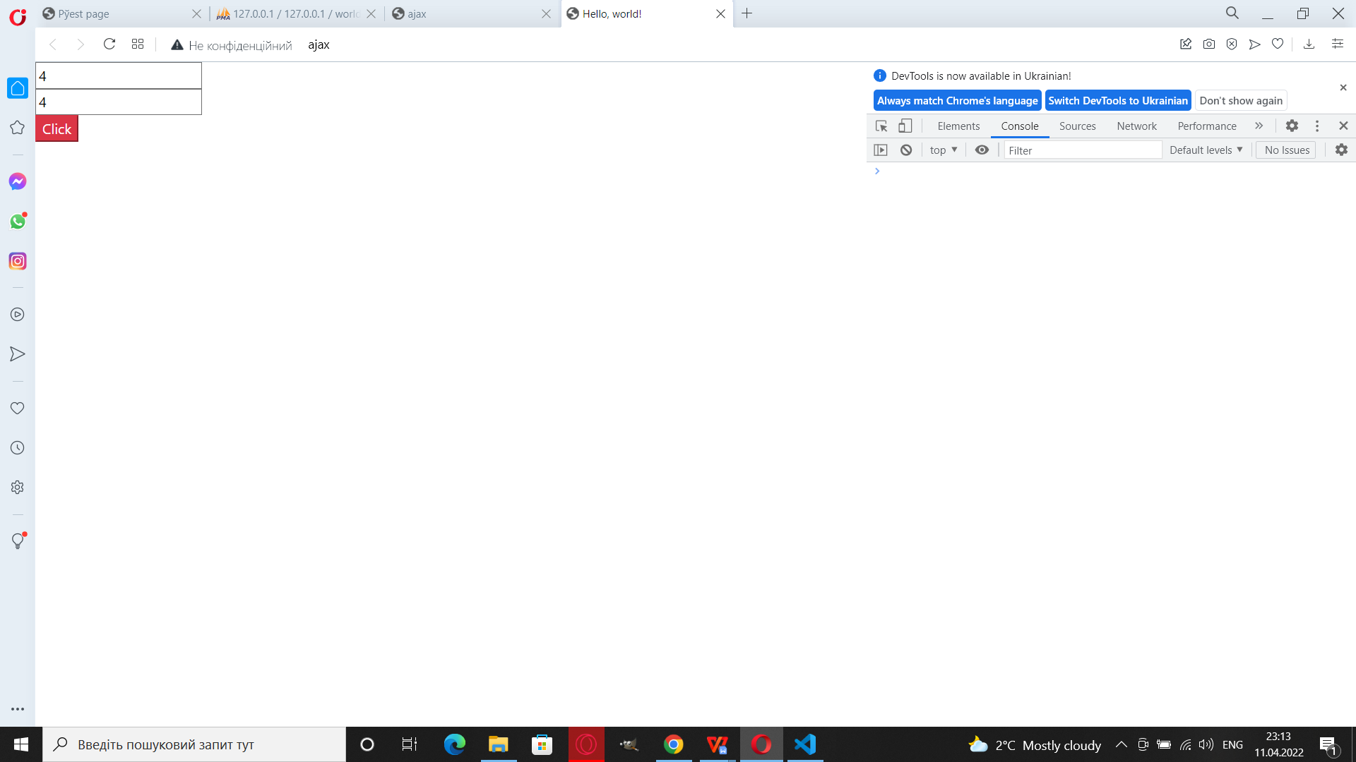

<!doctype html>

<html lang="en">

  <head>

    <meta charset="utf-8">

    <meta name="viewport" content="width=device-width, initial-scale=1">

    <script src="https://code.jquery.com/jquery-3.6.0.js" integrity="sha256-H+K7U5CnXl1h5ywQfKtSj8PCmoN9aaq30gDh27Xc0jk=" crossorigin="anonymous"></script>

    <link href="https://cdn.jsdelivr.net/npm/bootstrap@5.0.2/dist/css/bootstrap.min.css" rel="stylesheet" integrity="sha384-EVSTQN3/azprG1Anm3QDgpJLIm9Nao0Yz1ztcQTwFspd3yD65VohhpuuCOmLASjC" crossorigin="anonymous">

    <title>Hello, world!</title>

  </head>

  <body>

<input type="text" id="num1"><br>

<input type="text " id="num2" class="input"><br>

<input type="button" value="Click" onclick="onclicks" class="btn-danger">

<div class="result"></div>

<script>

    num1 = document.querySelector('#num1');

    num2 = document.querySelector('#num2')

    function onclicks(){

let n1 = $('#num1').val();

let n2 = $('#num2').val();

$.ajax({

    type: 'POST',

    url: '/a1.php',

    date: 'num1=' + n1 + 'num2=' +n2,

    success: function(data){

        $('.result').html(data);

    }

})

    }

</script>

    <script src="https://cdn.jsdelivr.net/npm/bootstrap@5.0.2/dist/js/bootstrap.bundle.min.js" integrity="sha384-MrcW6ZMFYlzcLA8Nl+NtUVF0sA7MsXsP1UyJoMp4YLEuNSfAP+JcXn/tWtIaxVXM" crossorigin="anonymous"></script>

    <script src="https://cdn.jsdelivr.net/npm/@popperjs/core@2.9.2/dist/umd/popper.min.js" integrity="sha384-IQsoLXl5PILFhosVNubq5LC7Qb9DXgDA9i+tQ8Zj3iwWAwPtgFTxbJ8NT4GN1R8p" crossorigin="anonymous"></script>

    <script src="https://cdn.jsdelivr.net/npm/bootstrap@5.0.2/dist/js/bootstrap.min.js" integrity="sha384-cVKIPhGWiC2Al4u+LWgxfKTRIcfu0JTxR+EQDz/bgldoEyl4H0zUF0QKbrJ0EcQF" crossorigin="anonymous"></script>

  </body>

</html>